Anthony Redamonti

Syracuse university

Homework 7

CIS-623 structured programming & formal methods

prof. Mehmet kaya

3/10/2022

Question 1:

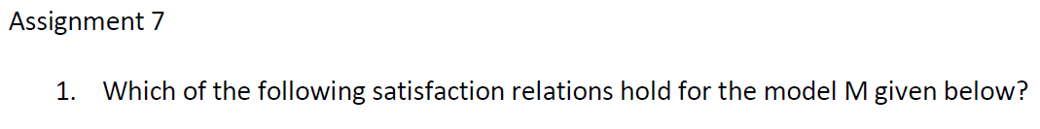

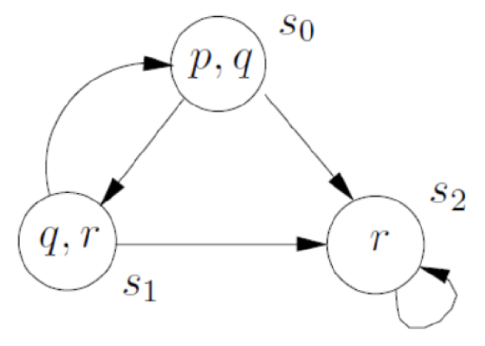

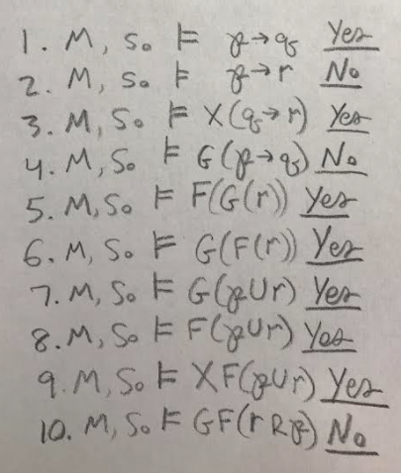

Question 2:



